**TEST PLAN TEMPLATE**

**Overview**

Now in our society, technology is the most important advancement, necessity in bringing out progress we move along in this latest technology to impress our client such that to be implemented and give them opportunity to come up with a computer. Some of their branches are

The main goal of the project is to provide a good quality of a system that will help mainly the Pharmacist at the hospital to automate the paper work that will help them to provide a good quality and quick service to each patient.

**Bounds**

Our system is needed to test the following:

* Functional Decomposition
* Databases:
* Search module
* Stock Record
* Stock Record Item
* Stock Record Forms
* Return Item
* Return Slip Form

**Scope**

The Cruz-Rabe Maternity & General Hospital Pharmaceutical Management System will be managed by the head of pharmacy. The main functionality of the system is to automate the easy access of the medicine information e.g. its location and its inventory information. This system is only accessible within the organization.

The objectives of this system are the following:

* To provide an easy to understand interface for the user.
* To provide a fast and reliable transaction between the pharmacist and the patient.
* Easy access of the inventory of the medicine.
* Easy to search of the location of the medicine.
* It can only be accessed within the organization.
* User Friendly graphical user interface.

**Definitions**

**Project Specific Language**

**General Terms**

**Functional Decomposition:**

* + A technique used during planning, analysis and design; creates a functional hierarchy for the software.

**Setting**

**QualityRisks**

Some of the problem that may encounter of the team might be the following:

* **Time management** – They might not meet the deadlines.
* **Misunderstanding between the client and the developers** – Scope of the system should be clear between the client and the developers so that the requirements that are needed to complete the system should be made by the team.
* **Communication of the team** – The team might have a problem in their main goal in doing the project. Everyone should be in the right path so that they have one goal that they are targeting.

Some of the problem that may encounter in technical aspect might be the following:

* System might be inaccessible if there is blackout.
* 2 Who will support the system after the implementation? System support team should be formed to support the system.
* Computer might be exposed into viruses/malware that can result into data leakage. Anti-virus software should be installed and always updated.

**Proposed Schedule of Milestones**

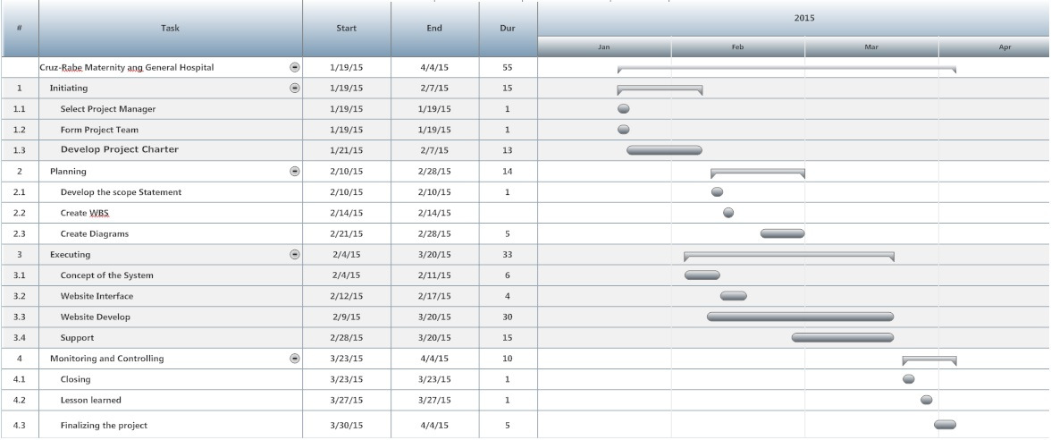

**Transition**

**Entry Criteria**

**Stopping Criteria**

**Exit Criteria**

**Test Configurations and Environments**

The Specific Requirements to run a test for the system are the following:

* Desktop Computers/Laptops should be running in Windows 7 operating system.
* There is an internet connection in Desktop Computers/Laptops.
* User manuals should be distributed and review by the users before testing the software.

**Test Execution**

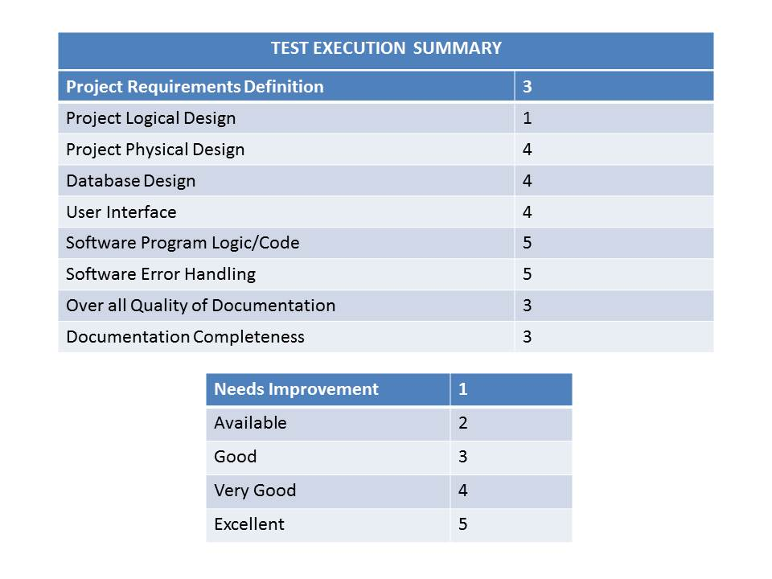 **Resources**

**People**

* Project Manager –is the person who has the overall responsibility for the successful initiation, planning, design, execution, monitoring, controlling and closure of a project.
* System Developer- may take part in design, computer programming, or software project management.
* Business Analyst- is someone who analyzes an organization or business domain (real or hypothetical) and documents its business or processes or systems, assessing the business model or its integration with technology.
* Software Quality Assurance - consists of a means of monitoring the software engineering processes and methods used to ensure quality.

**Tools**

* Notepad++
* XAMPP
* Microsoft Word

**Software**

* Yii Framework
* phpMyAdmin
* Browser(Google Chrome ,Mozilla Firefox)

.

**Hardware**

* Desktop Computer
* Laptop
* Windows XP (32bit/64bit)
* Windows 7 (32bit/64bit)

**Network**

* Apache
* MySQL

**Other resources**

* Photoshop CS3
* Sony Camera
* Google

**Test Case and Bug Tracking**

• Systems that help track and manage test execution and discovered bugs

**Bug Isolation and Classification**

• Degree you intend to isolate bugs

• Method you’ll use to classify bug reports

**Release Management**

• Mandate versioning

• Establish new release format

• Expectations around release acceptance (partial builds between test cycles)

**Test Cycles**

• usenumericscheme3.1,3.1.1, 3.1.1.1…

• definetest suite

**Risks and Contingencies**

While doing the testing of the prototype it is prone in different kind of risks.

Testers should be provided of Users manual so that they can easily know where to navigate or what should they click.

Additional support for the debugging should be implemented if there is a big problem resolving in the error.

**Change History**

Record changes and revisions that have been made to test plan itself.

**ReferencedDocuments**

w

<http://projects2.apc.edu.ph/wiki/index.php/CSPROJ2_MI121_Group_4:_Team_Leader:_Barbasa%2C_Mark_Ervin_T._BSIT-MI121>

Specifications, requirements, configuration tables,automation scheme, templates and examples.